**ASSIGMENT JAVA DAY7**

**Harshit Kushmakar| 16896**

**1. Write a program to demonstrate the use of try, catch, finally throw and throws keywords and demonstrate the following points in the program.**

**a) Multiple catch blocks.**

package assignment7;  
import java.util.Arrays;  
  
public class MultiCatch {  
 public static void main(String[] args) {  
  
  
  
 System.*out*.println("main begin");  
 try {  
 int a[] = new int[5];  
 a[10] = 5 / 0;  
 // Here try followed by 2 catch blocks  
 } catch (ArithmeticException e) {  
 // this catch is to handle ArithmeticException  
 System.*out*.println("ArithmeticException raised");  
 } catch (ArrayIndexOutOfBoundsException e) {  
 // this catch is to handle ArrayIndexOutOfBoundsException  
 System.*out*.println("ArrayIndexOutOfBoundsException raised");  
 }  
 System.*out*.println("main end");  
  
 }  
 }

**OUTPUT:**

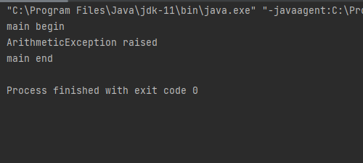

**b) try-catch-finally combination.**

package assignment7;  
import java.util.Arrays;  
  
public class MultiCatch {  
 public static void main(String[] args) {  
  
 System.*out*.println("main begin");  
 try {  
 System.*out*.println("try block : Risky code");  
 int result = 5 / 5;  
 System.*out*.println("result: " + result);  
 } catch (ArithmeticException e) {  
 System.*out*.println("catch-block : Handling ArithmeticException");  
 } finally {  
 // finally executes as exception not raised  
 System.*out*.println("finally block : Always executes");  
 }  
  
 System.*out*.println("main end");  
 }  
 }

**OUTPUT:**

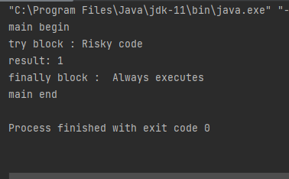

**c) try-finally combination.**

package assignment7;  
  
public class TryFinally {  
  
 public static void main(String[] args) {  
  
 System.*out*.println("main begin");  
 try {  
 System.*out*.println("try block : Risky code");  
 System.*out*.println(5 / 5);  
 } finally {  
 // finally executes as exception not raised  
 System.*out*.println("finally block : Always executes");  
 }  
 System.*out*.println("main end");  
 }  
}

**OUTPUT:**

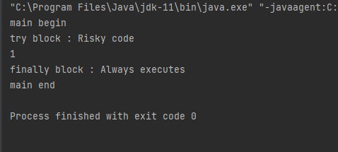

**d) Exception propagation among many methods.**

package assignment7;  
  
public class ExceptionProp {  
 public void method1() {  
 int result = 5 / 0;  
 // exception propagated to method2()  
 }  
  
 public void method2() {  
 method1();  
 // exception propagated to method3()  
 }  
  
 public void method3() {  
 try {  
 method2();  
 // if not handled here exception propagated to main() method  
 } catch (ArithmeticException e) {  
 System.*out*.println("exception handled");  
 }  
 }  
  
 public static void main(String args[]) {  
 // // if not handled in main() method exception propagated to  
 // defaultExceptionHandler  
 System.*out*.println("main() begin");  
 ExceptionProp obj = new ExceptionProp();  
 obj.method3();  
 System.*out*.println("main() end");  
 }  
}

**OUTPUT:**

**e) Nested try blocks.**

package assignment7;  
  
public class NestedTryBlocks {  
 public static void main(String[] args) {  
  
 try {  
  
 // initializing array  
 int a[] = {1, 2, 3, 4, 5};  
  
 // trying to print element at index 5  
 System.*out*.println(a[5]);  
  
 // try-block2 inside another try block  
 try {  
  
 // performing division by zero  
 int x = a[2] / 0;  
 } catch (ArithmeticException e2) {  
 System.*out*.println("division by zero is not possible");  
 }  
 } catch (ArrayIndexOutOfBoundsException e1) {  
 System.*out*.println("ArrayIndexOutOfBoundsException - Element at such index does not exists");  
 }  
 }  
// end of main method  
  
}

**OUTPUT:**

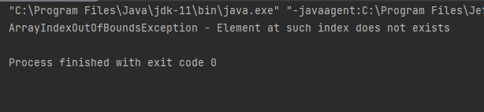

**2. Write a program to throw a checked exception explicitly using 'throw' keyword and**

**a) Handle the exception in same method.**

package assignment7;  
  
import java.io.IOException;  
  
public class CheckedExcep {  
 public static void function1() throws IOException {  
 boolean a = true;  
 try {  
  
 if (a) {  
 throw new IOException("Checking checked exceptions");  
 }  
 } catch (IOException e) {  
 System.*out*.println("caught in function1: " +e.getMessage());  
 }  
 }  
 public static void function2() {  
 try{  
 *function1*(); // // handling exception in other method  
  
 }  
 catch (Exception e){  
 System.*out*.println("caught in function2:" +e.getMessage());  
 }  
 }  
 public static void function3() throws IOException{  
 throw new IOException("Exception in function3 : ");  
  
 }  
  
 public static void main(String[] args) throws Exception{  
 *function2*();  
 *function3*();  
 }  
}

**OUTPUT:**

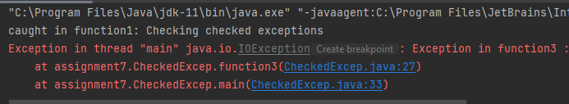

**b) use throws clause and handle the exception in some other method (calling method) .**

**c) Don't either handle or use the throws clause.**

package assignment7;  
  
import java.io.IOException;  
  
public class CheckedExcepArthimetic {  
 public static void function1() throws IOException {  
 boolean a = true;  
 try {  
  
 if (a) {  
 throw new IOException("Checking checked exceptions");  
 }  
 } catch (ArrayIndexOutOfBoundsException e) {  
 System.*out*.println("caught in function1: " + e.getMessage());  
 }  
 }  
  
 public static void function2() {  
 try {  
 *function1*(); // // handling exception in other method  
  
 } catch (Exception e) {  
 System.*out*.println("caught in function2:" + e.getMessage());  
 }  
 }  
  
 public static void function3() throws IOException {  
 throw new IOException("Exception in function3 : ");  
  
 }  
  
 public static void main(String[] args) throws Exception{  
 CheckedExcepArthimetic.*function2*();  
 CheckedExcepArthimetic.*function3*();  
 }  
 }

**OUTPUT:**

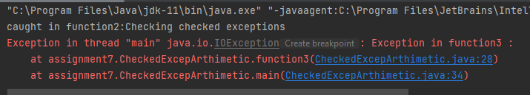

**3. Write a program to throw an unchecked exception explicitly using 'throw' keyword and**

**a) Handle the exception in same method.**

**b) use throws clause and handle the exception in some other method (calling method)**

**c) Don't either handle or use the throws clause.**

package assignment7;  
  
public class UncheckedExcep {  
 public static void function1() throws ArithmeticException {  
 System.*out*.println(12 / 0);  
 }  
 public static void function2() {  
 try {  
 *function1*();  
 } catch (ArithmeticException e) { // Handling expression in other method(3(b))  
 System.*out*.println("Handling arithmetic exp in funcExp2 : " + e.getMessage());  
 }  
 }  
 public static void function3() {  
 try { // Handling expression in same method  
 int a = 12 / 0;  
 } catch (ArithmeticException e) {  
 System.*out*.println("In funcExp3 catch : " +  
 e.getMessage());  
 }  
 }  
 public static void main(String[] args) {  
 UncheckedExcep.*function2*();  
 UncheckedExcep.*function3*();  
 }  
}

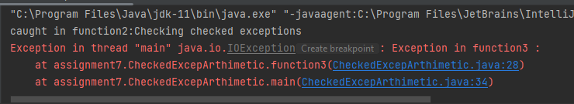

**4. Write a program in which main method calls the foo method which calls the bar method. Bar method can throw a checked exception. Use throws for throwing the exception from bar. Don’t handle exception in bar using try catch. Let the calling function handle the same.**

package assignment7;  
  
import java.io.IOException;  
  
public class ExceptionHandling {  
 public static void bar() throws IOException {  
 boolean b = true;  
 if (b) {  
 throw new IOException("Exp from bar");  
 }  
 }  
 public static void foo() {  
 try {  
 *bar*();  
 } catch (Exception e) {  
 System.*out*.println("Handling bar method : " +  
 e.getMessage());  
 }  
 }  
 public static void main(String[] args) {  
 *foo*();  
 }  
  
}

**OUTPUT:**

